Karim El-zubi, PhD
Professor & Dean
College of Pharmacy
QU Health
Qatar University, PO Box 2713, Doha, Qatar.
Tel: (+974) 4403-5550(GMT +3hrs)
Email: karim@qu.edu.qa

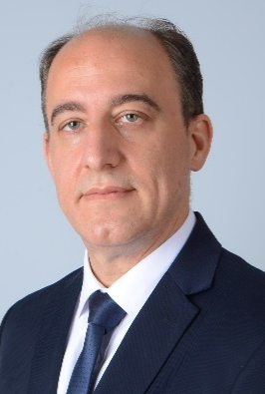

Prof. Karem H. Alzoubi is the Dean of the College of Pharmacy and professor of Pharmacology at Qatar University, Doha, Qatar. He holds a Ph.D. in Pharmacology from the College of Pharmacy at the University of Houston, TX, USA. He is the Ex-Dean of the College of Pharmacy at the University of Sharjah/Sharjah/UAE and the Faculty of Pharmacy at Jordan University of Science and Technology, Jordan. He co-founded the MSc program in Bioethics and the Responsible Conduct of Research Fellowship, a joint international degree with the University of California/USA. He has published over 657 publications in distinguished international journals. His current Scopus h index is 56 (total citations: >21000, Nov 2025). He was recognized as the Jordan Science Star-Pharmacology, A Royal Recognition by His Majesty King Abdullah II bin Al Hussein-2017. He was awarded the Khalifah Award for Education (an international award) by the government of the United Arab Emirates (UAE) under the patronage of H.H., the President of the UAE, Abu Dhabi, UAE (2014-2015). He was also granted several regional and international research and education excellence prizes, such as the Distinguished Researcher Award from the Ministry of Higher Education and Scientific Research, Amman, Jordan (2013), The Ali Mango Award for Distinguished Researcher in Medical Sciences, The University of Jordan, Amman, Jordan, (2013), Abdul Hameed Shoman Young Arab Investigator Award for Medical Sciences, the Shoman Forum, Amman, Jordan (2012), Hisham Hijjawi Award/Applied Science in the field of Industry and Energy, Jordan (2008). His research focuses are on research ethics and responsible research conduct, neuroscience/neuropharmacology of learning and memory, neuroprotection from neurodegenerative diseases, E-cigarettes, waterpipes, and toxicity of tobacco products, genotoxicity of drugs and chemicals, neurogenic hypertension, pharmacogenetics, and health services policies, guidelines, and implementation. Dr. Alzoubi has supervised over 100 master's and PhD candidates. He is a member of several national and international scientific and professional societies. He is also a reviewer for more than 50 national, regional, and international journals, funding agencies, and scientific societies, and he has been an evaluator for several scientific awards. Dr. Alzoubi has consulted several regional and international contract research organizations, higher education, quality assurance and accreditation agencies, pharmaceutical corporations, and drug regulatory agencies. He has also PI-ed and Co-PI-ed several multicenter international clinical and pre-clinical drug development studies.

Scopus: https://www.scopus.com/authid/detail.uri?authorId=8579544200

PubMed: https://pubmed.ncbi.nlm.nih.gov/?term=alzoubi+k&sort=date&sort_order=desc

Daoud Al-Badriyeh, BPharm(Honors), PhD
BPharm Honors (Uni of Sydney, Australia), PhD (Monash Uni, Australia)

Professor of Health Economics & Outcomes Research
Graduate Studies Coordinator
College of Pharmacy, QU Health
Qatar University
Daoud.a@qu.edu.qa

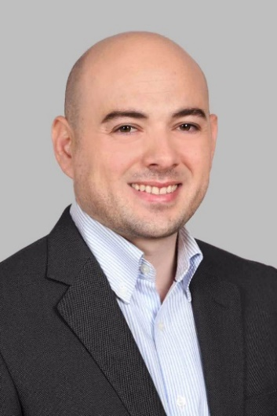

Dr. Daoud Al-Badriyeh completed an honors degree in pharmacy at the University of Sydney (Sydney, Australia), and then received his PhD in pharmacoeconomics from Monash University (Melbourne, Australia). Dr. Daoud also completed specialized training in healthcare analytics, patient safety and medical errors, and medical statistics.
Currently, Dr. Daoud is a Professor of Pharmacoeconomics and Outcomes Research and is the Head of Graduate Studies at the College of Pharmacy of Qatar University, Qatar, and is an adjunct faculty member at Monash University, Australia.
Dr. Daoud has over 140 peer-reviewed publications, including over 90 research articles, and has over 150 conference presentations. He supervised over 20 postgraduate students so far, and has over QAR 6 Million in accumulated research funds.
Dr. Daoud’s research mainly focuses on pharmacoeconomics, health economics, and decision-analytic simulation, as well as comparative effectiveness research and the economic impact of hospital services.
Dr. Daoud is also the Founder and current President of the Qatar Chapter of the International Society of Pharmacoeconomics and Outcomes Research (ISPOR, USA). He is also the Lead of the Health and Business Research Network Group at Qatar University, Qatar.

College webpage, including postgraduate research interests: http://qufaculty.qu.edu.qa/daoud-a/

PubMed: https://pubmed.ncbi.nlm.nih.gov/?term=al-badriyeh&sort=date

Google Scholar: https://scholar.google.com/citations?user=oxS4bikAAAAJ&hl=en

Alaaldin M. Alkilany
Professor of Pharmaceutics and
Nanotechnology/Research Coordinator at the College of Pharmacy
BSc (Pharmacy) (Jordan University of Science and Technology, Jordan); PhD (University of Illinois at Urbana-Champaign, USA)
Professor of Pharmaceutics and Nanotechnology
Phone: +974 4403-5578
Fax: +974 4403-5551
Email: alkilany@qu.edu.qa

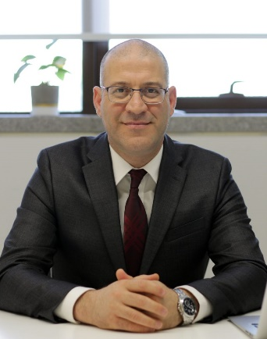
Biography:

Prof. Alaaldin Alkilany is Professor of Pharmaceutics and Nanotechnology at Qatar University, where he also serves as Research Coordinator for the College of Pharmacy. He earned his PhD from the University of Illinois, USA, and completed postdoctoral training at the University of Georgia.
With extensive experience in pharmaceutical manufacturing, Prof. Alkilany has worked with leading organizations, including Eli Lilly (USA) and Hikma Pharmaceuticals (Jordan), contributing to the development of more than twenty products for regulated markets. Most recently, he developed Q-Silvano hydrogel, officially registered by the Ministry of Public Health in Qatar and manufactured by QLife Pharma—the first nanotechnology-based medical product from Qatar University to reach the market.
Prof. Alkilany is recognized internationally for his scholarly contributions, with over 75 publications cited more than 19,000 times. He is a recipient of the prestigious Alexander von Humboldt Fellowship (Germany) and has been consistently listed among Stanford’s Top 2% Scientists worldwide. His research centers on the design and application of nanomaterials for drug delivery and other biomedical innovations.

Researchgate link: https://www.researchgate.net/profile/Alaaldin-Alkilany

Google Scholar: https://scholar.google.com/citations?user=QW-zKs8AAAAJ&hl=en

Scopus: https://www.scopus.com/authid/detail.uri?authorId=23468628100

Muhammad Abdul Hadi, PhD
Pharm (Punjab University, Pakistan), MClinPharm (USM, Malaysia), PGCertHE (De Montfort University, UK), PhD (University of Leeds, UK)
Associate Professor of Clinical Pharmacy and Practice
College of Pharmacy
Room S2.10, I06 Building
E-mail: mabdulhadi@qu.edu.qa

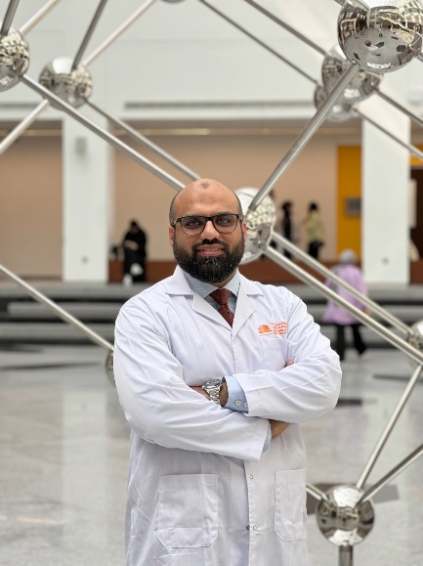
Biography

Dr. Muhammad Abdul Hadi is an Associate Professor of Clinical Pharmacy and Practice at the College of Pharmacy. He is a pharmacist by training and completed his PhD in pharmaceutical health services research from the University of Leeds in 2014.
Prior to joining Qatar University, he was an Associate Professor of Pharmacy Practice and Policy at the University of Birmingham, UK. At Birmingham, Dr. Hadi was the Programme Director of the Independent Prescribing Programme and Chair of the School of Pharmacy’s Research Ethics Committee. In the past, he has held various academic at Universiti Teknologi MARA (UiTM), Malaysia, Monash University Malaysia, Umm-Al-Qura University (Saudi Arabia), University of Leeds (UK), and De Montfort University (UK),
Dr. Hadi’s main research interests include: health services research, medicines safety, use and optimization and pharmacy education. He is a research methodologist and likes to work across different clinical disciplines. He has successfully supervised MSc and PhD students to completion. Dr. Hadi has published over 95 papers in international peer-reviewed journals. Dr. Hadi is also the Associate Editor of BMC Health Services Research and and section editor for the Journal of Pharmaceutical Policy and Practice. He is a mentor for the Pharmacy Research UK and faculty at the National Institute of Health Research (NIHR). He is a Fellow of the Higher Education Academy, UK and the Royal Society of Public Health. His name was recently included in the top 2% of scientists published by Stanford University and Elsevier.

Research Interest:
Medication Safety
Health Services Research
Pain management and quality use of medicines
Pharmacy Administration and Social Pharmacy
Pharmacy Education

Mohamed Izham B. Mohamed Ibrahim, PhD
Professor of Social & Administrative Pharmacy
College of Pharmacy
QU Health
Building I – 06, Second Floor Room SA2.13
Qatar University, PO Box 2713, Doha, Qatar.
Tel: (+974) 4403 5580 (GMT +3hrs)
mohamedizham@qu.edu.qa



Dr Mohamed Izham is a Professor of Social and Administrative Pharmacy at the College of Pharmacy, QU Health Sector, Qatar University. He obtained his PhD degree in Pharmacy Administration from the Philadelphia College of Pharmacy & Science (PCPS), Philadelphia, USA, in 1995.
His areas of research, publication and consultancy are in the area of Social & Administrative Pharmacy in Low- and Middle-Income Countries (LMICs) that focus on Pharmaceutical Policy & Supply Management, Pharmacoeconomics, Pharmacoepidemiology, Socio-behavioral Aspects of Pharmacy, and Pharmaceutical Management & Marketing. Dr. Izham has supervised and/or participated in training around 100 MSc and PhD graduate students from 15 countries. He has published 14 books and more than 300 articles. He won the 2015 Qatar University Scopus Medical & Health Sciences Scientist Award. He has also functioned in multiple consultant roles to the agencies and governments of Malaysia, Sudan, Mongolia, Qatar, and non-governmental bodies at national and international levels (e.g. WHO, Health Action International). He is an external examiner/ program reviewer/visiting professor/board member for a few Malaysian universities (i.e. IIUM, UKM, UnisZa, USM and UniKl), in Nepal and Sudan.
He was formerly a Professor at the School of Pharmaceutical Sciences, Universiti Sains Malaysia, and the College of Pharmacy, Qassim University, Al-Qassim, KSA, and the founding program coordinator of the Healthy Campus Programme, as well as the Director of the Corporate & Sustainable Development Division at Universiti Sains Malaysia, Malaysia. He was also the Associate Dean of Research and Graduate Studies (Pharmacy) at the University Sains Malaysia and the College of Pharmacy, Qatar University. His last post was as the Acting Dean at the Qatar University College of Pharmacy

Scopus: https://www.scopus.com/authid/detail.uri?authorId=57195534191
Mendeley: https://www.mendeley.com/profiles/mohamed-izham-mohamed-ibrahim2/
Researchgate: https://www.researchgate.net/profile/Mohamed_Izham_Mohamed_Ibrahim?ev=hdr_xprf
Google Scholar: https://scholar.google.com/citations?hl=en&user=uuUGCzkAAAAJ&view_op=list_works&sortby=pubdate
ORCID: https://orcid.org/0000-0001-9757-3574
Loop: https://loop.frontiersin.org/people/363569/overview

Dr.Kazeem Yusuff, BPharm, MPharm, PhD
BPharm, MPharm (Clinical Pharm), PhD (Clinical Pharm) (Nigeria)
Professor of Clinical Pharmacy and Practice
College of Pharmacy
Qatar University
kyusuff@qu.edu.qa

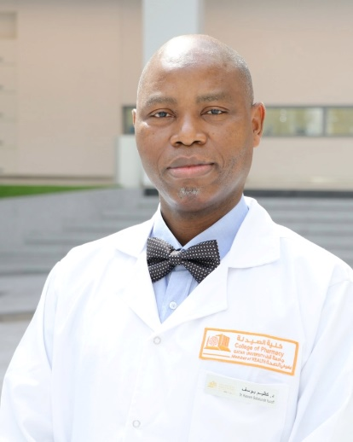

Dr. Kazeem Babatunde Yusuff is a professor of clinical pharmacy and practice and a thoroughbred academic with an impassioned commitment to making a difference that benefits at the individual and, organizational levels. He obtained his Bachelor of Pharmacy (Hons) from the University of Ife, now Obafemi Awolowo University in 1987, Master of Pharmacy (Distinction) and Doctor of Philosophy from the University of Lagos, Nigeria in 2000 and 2008 respectively. Dr Kazeem joined the Department of Clinical Pharmacy and Pharmacy Administration, Faculty of Pharmacy, University of Ibadan, Nigeria as Lecturer II in 2002, was promoted to Lecturer I in 2005 and Senior Lecturer in 2009. He had an exciting 15-month academic adventure in the Department of Pharmacy Administration and Practice, Rhodes University, South Africa. In pursuit of his career vision for outstanding excellence, he joined the College of Clinical Pharmacy, King Faisal University, Saudi Arabia in 2012, and was promoted to the associate professor grade in November 2016. Dr Kazeem joined the College of Pharmacy at Qatar University (QU) as an associate professor of clinical pharmacy and practice in January 2019 and was promoted to the full professor rank in July 2023.
Dr Kazeem has successfully supervised several research projects at both undergraduate and postgraduate levels, and has also served as internal and external examiner for master and PhD projects in Nigeria and South Africa. He has also received and efficiently managed generous funds from QU (internal grants) and Qatar National Research Fund (UREP grants). Dr. Kazeem has published several original research articles in varieties of leading high-quality reputable peer-reviewed international journals, and currently serves as an associate editor to two high quality peer-reviewed international journals (PLOS ONE and BMC Health Services Research).
Dr Kazeem has served with distinction in several administrative positions in Nigeria, South Africa, Saudi Arabia and Qatar. A few of these administrative engagements include acting sub-dean (undergraduate) and acting Head of the Department (University of Ibadan, Nigeria), Chair, Postgraduate Committee (King Faisal University, Saudi Arabia), Member, Higher Degrees Committee, (Rhodes University, South Africa), Chair, Program Learning Outcome Assessment Committee (Qatar University, Qatar) and Head of Department, Clinical Pharmacy and Practice (Qatar University, Qatar).

Nashiru Billa
Professor of Drug Delivery
BPharm; PhD
Professor of Pharmaceutics
College of Pharmacy
Qatar University
E-mail: nbilla@qu.edu.qa

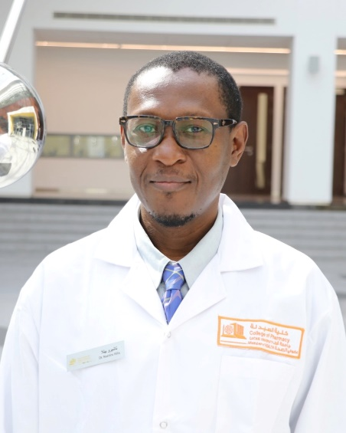

Dr Billa is a Professor of Pharmaceutics at the College of Pharmacy, Qatar University. He is a Pharmacist and obtained his PhD in Pharmaceutical Technology from the University of Science, Malaysia in 2000, after a brief an attachment at a Pharmaceutical Industry. He Joined the International Medical University in 2001 as a Lecturer in Pharmaceutics and the Chief Scientist of the EQUILAB Bioequivalence laboratory in the same University, where he oversaw the execution of bioequivalence studies to Pharmaceutical Industries. In 2005, He joined the School of Pharmacy, University of Nottingham, Malaysia Campus as an Assistant Professor and was promoted to Associate Professor in 2007 and to full Professor in 2015. During his 15-year engagement at the University of Nottingham, he held several administrative positions, including Associate Dean for Research & Knowledge Exchange and Deputy Head of School. Dr Billa is recipient of numerous University, National and International grants, including a Euro FP7 Bio-design collaborative research grant worth 1million euros aimed at deciphering the fate of growth factors in bone tissue engineering. He has served as a consultant to a Pharmaceutical Company and participated more than 32 bioequivalence studies on generic pharmaceuticals products to sponsors. He has published over 90 peer-reviewed journals, supervised 2 Postdoctoral candidates, 18 PhD and 15 MSc candidates as primary supervisor. He has also served as External Examiner to 23 PhD student theses. Dr Billa’s research interest is primarily aimed at improving the bioavailability of drugs via novel technologies such as nanoparticle formulation. Emphasis is on the use of natural therapeutics of plant origin, especially anticancer agents and the use of biodegradable/biocompatible excipients and oral delivery of developed nanoparticle formulations. These are typically polymeric, solid lipid and nanostructured lipid carriers (SLN & NLC). He is also interested in the application of in vitro and in vivo models in understanding the performance of nanoparticle deployment into and across epithelia. Other research interest involves the application of 3D printing technology in the development of drug delivery systems and biomedical devices.

https://www.scopus.com/authid/detail.uri?authorId=6508377305
https://scholar.google.com/citations?user=eW3jcVYAAAAJ&hl=en

Hesham M. Korashy, PhD
BSc (Pharmaceutical Sciences), PhD (Pharmacology and Toxicology)
(U of Alberta, Canada)
Professor of Pharmacology and Toxicology
Associate Dean for Academic Affairs
College of Pharmacy
Qatar University
E-mail: hkorashy@qu.edu.qa

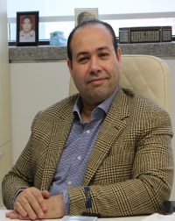

Dr. Korashy is a Professor of Pharmacology and Toxicology in the Department of Pharmaceutical Sciences at Qatar University’s College of Pharmacy, as well as the Associate Dean for Academic Affairs since Fall 2024. He received his bachelor’s degree in pharmacy from King Saud University, Saudi Arabia, and his PhD in pharmacology and toxicology from the University of Alberta, Canada, in 2007. Prof. Korashy began his career at King Saud University as an Assistant Professor in 2008, then was promoted to Associate Professor in 2012, and finally to Full Professor in 2017. From 2012 to 2017, he headed the Quality and Development department at King Saud University’s College of Pharmacy.

Prof. Korashy possesses extensive teaching experience teaching pharmacology and toxicology to undergraduate and graduate students at various colleges, including pharmacy, medicine, and biomedical sciences spanning over two decades across prestigious institutions in Canada, Saudi Arabia, and Qatar. As a professor of pharmacology and toxicology, he is deeply committed to fostering critical thinking, scientific curiosity, and integrative learning among his students. His teaching philosophy emphasizes student-centered learning, outcome-based education, and the development of knowledge, skills, and communication. He advocates for active engagement through lectures, team-based learning, and problem-solving discussions, while ensuring fairness in assessment and clarity in expectations. He has had a significant impact on curriculum design and development, as well as active participation in pharmacy program accreditation processes in Qatar and Saudi Arabia via the Canadian Council for Accreditation of Pharmacy Programs (CCAPP) and the Accreditation Council for Pharmacy Education (ACPE). Furthermore, Prof. Korashy has participated in QU’s Pedagogical Professional Development Program to improve teaching and learning practices.

Prof. Korashy is well known for his work in molecular oncology of cancer stem cells and environmental toxicology, both regionally and globally. He achieved distinction by being ranked in the top 2% of highly cited scientists by Stanford University in 2023 and 2024, as well as a prominent position in the AD Scientific Index’s Top Subject Field Ranking. His primary research interests include the impact of environmental factors and the cytochrome P450 pathway on cancer and cancer stem cell development to develop novel chemoprotective strategies. Prof. Korashy has successfully secured research grants exceeding 3 million Qatari riyals as LPI, supported by Qatar University and the Qatar Research, Development, and Innovation Council. He has over 109 peer-reviewed publications in prestigious journals such as Molecular Cancer (IF=44.4) and Seminars in Cancer Biology (IF=17) and has presented his research at numerous national and international conferences and meetings. Prof. Korashy has supervised more than 21 MSc and PhD theses and has served as an external examiner for several graduate programs at various universities. In addition, Prof. Korashy serves as an Associate Editor for the Journal of Translational Medicine, Frontiers in Pharmacology, and Cardiovascular Toxicology, as well as on the editorial boards for several other scientific journals. Dr. Korashy’s H-index is 43 with more than 5000 citations.

Prof. Korashy has held numerous academic and administrative positions at Qatar University, reflecting his significant contributions to enhancing the research and educational environment. He has been the chair of the Qatar University Academic Promotion Committee since 2022. He also chaired and co-chaired several university committees, including the Institutional Committee for Animal Care and Use (2020-2022), the Institutional Biohazard Committee (2019-2020), and the Health and Safety Committee at Qatar University Health Research Center. and served on numerous college and university committees, including the Pre-Award Committee at the Office of Research Support (since 2019), the Partnership and International Engagement Committee (2017–2018), the BSc Admission Committee, the Peer Assessment of Teaching and Learning Enhancement Committee, and the Graduate Studies Steering Committee. Furthermore, he has contributed to academic advancement through his membership on the Academic Promotion Committees of both the College of Health Sciences and the College of Pharmacy. His role in curriculum development is evident through his service on the College of Pharmacy Curriculum Committee (2017–2020) and the Graduate Studies Taskforce.

Prof. Korashy has received extensive recognition for his research excellence and mentorship, with numerous awards spanning over two decades. Notably, his students have earned top distinctions such as the Best PhD Dissertation Award (2024), Best MSc Thesis Award (2021), and multiple podium and poster presentation accolades at national and international forums, including the Royal College of Surgeons in Ireland Dual PhD award (2023), ITEX Gold Medal (2022, Malaysia), and Qatar’s National Science Research Week top prize (2023). His mentorship has also led students to success at competitive events like the Undergraduate Research Experience Program (QRDI) and QU Health Symposiums. Personally, he was honored with the Excellence in Research Award (2011) and the University of Alberta Dissertation Fellowship (2007), Queen Elizabeth II Graduate Scholarship Canada (2005), the International Pharmaceutical Students’ Federation in Rwanda, and the Dr. Walid Kayyali Award in Saudi Arabia, Health Research Graduate Scholarship from the Canada Institute and the Society of Toxicology Graduate Student Travel Award (USA), affirming his sustained contributions to scientific research and academic development.

PubMed: https://pubmed.ncbi.nlm.nih.gov/?term=korashy+h&sort=date
Google Scholar: https://scholar.google.com/citations?user=vwLn7bAAAAAJ&hl=en
ORCID: https://orcid.org/0000-0002-5745-9643

Hazem Elewa, RPh, PhD
Associate Professor and PharmD Director
College of Pharmacy
Department of Clinical Pharmacy and Practice, Qatar University
E-mail: Hazem.elewa@qu.edu.qa

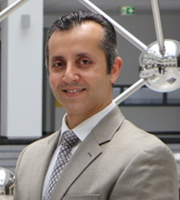

Dr.Hazem Elewa embarked on his academic pursuit by attaining a Bachelor’s degree in Pharmaceutical Sciences. Subsequently, he pursued his passion for research and clinical therapeutics, earning a Ph.D. in Clinical and Experimental Therapeutics from the esteemed University of Georgia, USA. Dr. Elewa further enhanced his expertise through a post-doctoral fellowship in pharmacogenomics at University of Florida, USA laying the foundation for his impactful contributions to the field of precision medicine. Since October 2010, Dr.Hazem served as a clinical pharmacist at Georgia regents medical center. Concurrently, his commitment to education and mentorship led to his appointment as an Adjunct Clinical Assistant Professor at the College of Pharmacy, University of Georgia, where he has also served as a clinical preceptor.

In 2013, Dr.Hazem Elewa embarked on a new chapter of his academic journey by joining the College of Pharmacy, Qatar University as Assistant Professor and was promoted to Associate Professor in 2019. He was also appointed as the Head of Clinical Education in 2018 and currently serves as the PharmD Director at the college. Dr.Elewa was cross-appointed at Alwakra Hospital and assisted in launching the first pharmacist-led anticoagulation clinic in Qatar. Complementing his clinical practice in the field of antithrombotics and cardiovascular disease, his research pursuits have been pioneering, with a focus on anticoagulation and personalized medicine through the utilization of pharmacogenomics. His contributions have not gone unnoticed, as Dr. Elewa has been the recipient of numerous national and international awards, alongside securing multiple grant funding to further fuel his research endeavors. Dr.Elewa has supervised several MSc and PhD graduate students, and he has published over 70 peer-reviewed publications, 3 book chapters, and numerous posters and oral presentations at international conferences.

https://scholar.google.com/citations?hl=en&user=UO2tpmAAAAAJ&view_op=list_works&sortby=pubdate
ResearchGate: https://www.researchgate.net/profile/Hazem_Elewa

Abdelbary Elhissi, PhD
BSc (Pharmacy); PhD (Pharmaceutics), HE Cert (Teaching & Learning)
Full Professor and Head of Pharmaceutical Sciences Department
College of Pharmacy
Department of Pharmaceutical Sciences,
College of Pharmacy (I06),
Qatar University, P.O. Box 2713, Doha, Qatar
E-mail: aelhissi@qu.edu.qa

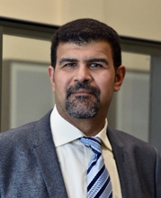

Abdelbary is a Professor in Pharmaceutics, and the Head of Pharmaceutical Sciences Department at the College of Pharmacy, Qatar University. Professor Elhissi combines a strong expertise in research at both academic and industrial levels. He obtained his PhD in 2005 from UCL School of Pharmacy and then worked as a postdoctoral research Fellow at UCL (2005-2006). He worked in Pharmaceutical Industry at Lipoxen Technologies Ltd, UK as Senior Scientist (2006-2007) with responsibility of developing anticancer nanomedicine formulations. Abdelbary joined the University of Central Lancashire (UCLan) in UK as Lecturer (2007-2011) and Senior Lecturer (2011-2014), where he was the lead of pharmaceutics and established one of the largest drug delivery research groups in UK. He served as Deputy Head and a founding member of the UCLan’s Institute of Nanotechnology and Bioengineering (2011-2014). Abdelbary moved to QU as Associate Professor at the College of Pharmacy in 2014 and was promoted to Professor in 2019. Parallel to this, Abdelbary is the Founding Manager of the Research Excellence Office (2017-2020) and then he served as Director of Research Planning and Development at QU (2020 – 2022). Abdelbary authored 88 peer-reviewed publications and 30 book chapters. He supervised/co-supervised 27 MSc and PhD students and secured over USD 2.6 Million for funding his research. He served as Visiting Professor at Sichuan University, China (2013-2016), and Anglia Ruskin University, UK (2022-present), and has extensive network and connections with many research active institutions worldwide. Abdelbary’s research area is focused on developing nanomedicine formulations for the treatment of cancer and pulmonary diseases. He is particularly interested in liposomes and proliposome technologies, and how nanoparticle delivery for inhalation is influenced by inhalation device technology. Abdelbary is among the top 2% World Scientists in terms of field citation impact according to Stanford University reports (2019, 2020, 2021, 2022 and 2023).

PubMed: https://pubmed.ncbi.nlm.nih.gov/?term=Elhissi
Google Scholar: https://scholar.google.com/citations?hl=en&user=eEHe5gIAAAAJ
Linkedin: https://qa.linkedin.com/in/professor-abdelbary-elhissi-99b92911a

Ousama Rachid, PhD
BSc (Pharmacy), PhD (Pharmacokinetics, U of Manitoba, Canada)
Associate Professor
College of Pharmacy
QU Health, Qatar University
E-mail: orachid@qu.edu.qa

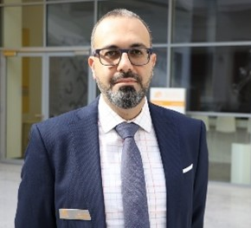

Dr. Ousama Rachid is an Associate Professor of Pharmaceutical Sciences at the College of Pharmacy, QU Health, Qatar University. He has over two decades of academic and research experience spanning drug delivery, biopharmaceutics, and pharmacokinetics, with prior appointments at the University of Manitoba (Canada) and Kuwait University.

Dr. Rachid’s recent research integrates computational pharmacokinetic (PK) modeling, physiologically based PK (PBPK) simulations, and population pharmacokinetics (popPK) to optimize drug dosing in special populations such as obese patients, pediatrics, and those with altered physiology. His group employs in silico tools including GastroPlus® and ADMET Predictor® to simulate systemic exposure profiles, advancing personalized dosing strategies and supporting model-informed precision dosing (MIPD).

In parallel, Dr. Rachid maintains active projects in nanomedicine and formulation science, focusing on drug delivery design and stability assessment under challenging environmental conditions. His portfolio includes over 35 peer-reviewed publications, supported by research funding exceeding one million USD. He is recognized for his extensive work in oromucosal drug delivery, particularly in the development of epinephrine sublingual tablets as needle-free alternatives for anaphylaxis management. This research led to multiple issued U.S. patents and successful technology licensing in collaboration with partners in Canada and the United States.

Dr. Rachid’s goal is to bridge computational prediction and experimental validation to improve therapeutic outcomes and advance precision dosing across diverse patient populations.

PubMed: https://pubmed.ncbi.nlm.nih.gov/?term=ousama+rachid&sort=date
Google Scholar: https://scholar.google.com/citations?user=6dL7oSwAAAAJ&hl=en&oi=ao

Hassaan Rathore
Associate Professor of Pharmaceutical Sciences
B.Pharm, PhD
College of Pharmacy
Qatar University
hrathore@qu.edu.qa

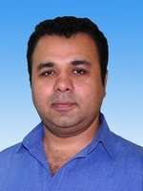

Dr. Hassaan Rathore is an Associate Professor at the College of Pharmacy, Qatar University and heading the assessment committee at CPH. He completed his bachelors in pharmacy from University of The Punjab, Lahore, Pakistan in the year 2001 and was awarded a doctorate degree in the field of physiology/pharmacy by the Universiti Sains Malaysia (USM), Penang in year 2009 where he served as a senior lecturer at the School of Pharmaceutical Sciences, until 2017. Previously he has worked as an Associate Professor and Head of the Department of Pharmacology & Toxicology, the Pharm D Program Coordinator and was a member of the strategic planning committee at the University of Hail, KSA. He has also been a visiting academician at the School of Pharmaceutical Sciences, Universiti Sains Malaysia, Penang and a visiting professor at the Lahore College of Pharmaceutical Sciences, Lahore, Pakistan.

At Universiti Sains Malaysia, he had his own independent research program in the area of cardiovascular & renal physiology and pathophysiology and developed the Hypertension and cardiovascular research laboratory (HCRLab) which had been generously funded by the Ministry of Science, Technology & Innovation, Malaysia (MOSTI) as well as by Universiti Sains Malaysia through several research grants to him as Principal Investigator (PI) over the past decade. He has published more than 55 research publications in renowned journals indexed and graded by ISI and Scopus and other well-known databases along with several conference proceedings, research reports and has contributed several book chapters. He has been invited at university, national and international levels to give seminars, conduct workshops, invited presentations, and has extensive experience in organizing national and international conferences in the field of pharmacy. Dr. Rathore has supervised 5 MSc and 6 PhD students who are now successful academicians, researchers and serving different governmental and non-governmental organizations in Malaysia, Pakistan, USA, Ireland, Libya and other countries.

He has keen interest in improving teaching-learning techniques especially in teaching of physiology to pharmacy students. He has been an active member of Physiology teaching group formed at IUPS 2009 in Kobe, Japan and has been a full member of the American Physiological Society, The Physiological Society UK and served as an editor to a quarterly newsletter of the Malaysian Society of Pharmacology and Physiology from 2005 to 2012.

He was a member of the institutional ethics committee for the use of animals in science at the university level and served the postgraduate research evaluation board of the school of pharmaceutical sciences. He has been both internal and external examiner of MSc and PhD theses at both national and international level and serves as reviewer for several renowned journals in the field of physiology and pharmacy. He was also appointed as the Associate editor of the Hail Journal of Health Sciences and a member of research committee, academic staff recruitment and promotion committees at University of Hail.

He was awarded the Excellence in service award at Universiti Sains Malaysia in 2013, Sangar Sanjung award for journal publication categories in 2013 and 2015. He received several travel awards from Federation of Asian Pharmacists Association (FAPA), The American Physiological Society (APS), The Physiological Society UK, Federation of Asian & Oceanian Physiological Societies (FAOPS) and a young investigator award by International Union of Physiological Societies (IUPS). He was also awarded the best student advisor at the College of Pharmacy, University of Hail, KSA.

Dr. Rathore’s expertise is teaching human physiology and researches via In vivo experimentation in cardiovascular & renal research areas. He is well trained in surgical manipulation of small animals including cannulation of carotid & iliac artery, jugular vein, tracheotomy etc. Surgical & chemical induction of different diseases such as left ventricular hypertrophy, heart failure, renal failure; hypertension models, diabetes, metabolic syndrome etc. were routinely developed in his laboratory. He also has extensive experience in the use of PowerLab® research and teaching systems, Millar’s PV catheters and MPV systems, small animal ECG, metabolic studies, renal and cardiovascular function studies etc.

PubMed: https://www.ncbi.nlm.nih.gov/myncbi/hassaan.rathore.1/bibliography/public/
Google Scholar: https://scholar.google.com.my/citations?user=VmBLShgAAAAJ&hl=en

Feras Alali, PhD
BSc (Pharm) (Jordan U Science and Technology, Jordan) PhD (Purdue U, USA)
Professor
Department of Pharmaceutical Sciences
College of Pharmacy
Email: feras.alali@qu.edu.qa

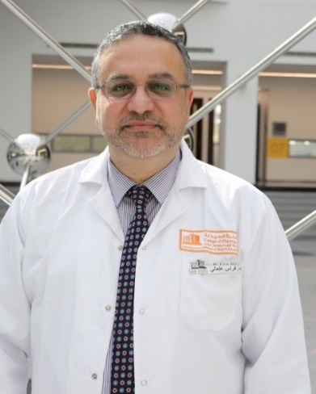

Prof. Alali was born in Dűsseldorf, Germany to a Jordanian family, married and a father of four children. Prof. Alali holds a Bsc in Pharmacy, Jordan University of Science and Technology (JUST) in 1992 (Excellent GPA), PhD in Medicinal Chemistry and Molecular Pharmacology/Chemistry of Natural Products 1994-1999, Purdue University (Top 10 USA Schools), Indiana (GPA 3.9/4.0). As of 9/2024, Prof. Alali is the Director of Research and Graduate Studies, QU Health, Qatar University, overseeing research and graduate studies at the Colleges of Medicine, Pharmacy, Dentistry, and Health Sciences. Dr Alali served in this same capacity in 2016-2021 as well, before serving as the Acting Dean of College of Pharmacy, Qatar University 2021-2024. During which, Dr Alali has established the Office of Research and Graduate Studies, QU Health, helped establish Biomedical and Pharmaceutical Research Unit, consolidate the PhD program, oversee establishment of QU Health College, oversee QU Health ranked for the first time in global and subject ranking, publications and grants witnessed tremendous annual growth. From Sept. 2013-2016, Prof. Alali served as the Associate Dean of Research and Graduate Studies, College of Pharmacy, Qatar University, Doha, Qatar.
Since 2013, Dr Alali is supporting QU in advancing health research, academic quality assurance, strategic planning, intellectual properties, research visibility, graduate programs, policy development and global and subject ranking. Prof. Alali has also served as the Dean of Pharmacy at JUST 9/2011 -9/2013, Dean of Pharmacy, Isra Private University, Amman, Jordan 2008-2009, Director and Founder, Pharmaceutical Research Center, JUST 2004-2007 and 2011-2013, Director, Center of Consultation, Community Services and Continuous Education, Isra Private University, Amman, Jordan 2008-2009, Vice and Assistant Dean, Faculty of Pharmacy, JUST 2000-2007.
Dr Alali served as Practical Training Researcher, Xenobiotic, New Jersey, USA 1998-1999, and Research Leave at Research Triangle Institute, North Carolina in 2004. Dr Alali is an expert in Drug Discovery and Development, Drug and Pharmaceutical Analysis and Quality Accreditation (Certified in IEC/ISO 17025), Certified Technical Assessor, member of Afro-Arab Pharmaceutical Organization for Standardization (APSO). Dr Alali supervised more than 30 Msc and Ph.D graduate students. Dr Alali was appointed as Assistant Professor at JUST in 1999 and promoted to full Professor in 2009 with 103 international, peer-reviewed publications, two book chapters and two USA patents.
Dr Alali was awarded the Highest National Recognition Award in Science - Pharmacy in Jordan in 2008 (Royal Decree). Currently, 2025, Dr Alali’s Elsevier Scopus h index is 30 with 3877 total citations, and Google Scholar h index of 36 and i10-Index of 78 with 6367 total citations. His research is focused on discovery and development of anti-cancer agents from natural resources.

Google Scholar: https://scholar.google.com/citations?user=J8NWBBgAAAAJ

Ahmed Awaisu, PhD
PhD (Clinical Pharmacy), MPharm (Clinical), BPham
Professor & Department Head, Clinical Pharmacy and Practice
College of Pharmacy
Qatar University
E-mail: aawaisu@qu.edu.qa

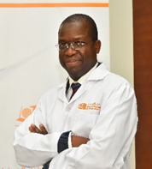

Ahmed Awaisu is a Professor of Clinical Pharmacy and Practice at the College of Pharmacy, Qatar University. He currently serves as the Head of the Department of Clinical Pharmacy & Practice (2020 – present). He earned his Bachelor of Pharmacy (BPharm) degree from Ahmadu Bello University, Zaria, Nigeria, in 1999, followed by a Master’s and a Ph.D. degree in Clinical Pharmacy from Universiti Sains Malaysia (USM) in 2004 and 2009, respectively. He is a licensed pharmacist since 1999 and has practiced in both hospital and academic settings. Prior to joining Qatar University, he served as Head of the Pharmacy Department at Rasheed Shekoni Specialist Hospital, Dutse, Jigawa State, Nigeria (2010–2011).
Prof. Awaisu brings extensive international academic experience in pharmacy education. He has held several academic and professional positions, including Lecturer at the International Islamic University Malaysia (IIUM) and USM (2005–2010), Central Facilitator for Nigeria’s National Program on Immunization (2005), and hospital pharmacist in various capacities in Jigawa State, Nigeria (1999–2011).
He was appointed Assistant Professor at the College of Pharmacy, Qatar University, in 2011. Prof. Awaisu has significantly contributed to the academic and professional development of undergraduate and postgraduate students. He has taught courses in therapeutics, pharmaceutical care, clinical pharmacokinetics, pharmacy practice, drugs in sport, and research design and biostatistics. His teaching philosophy emphasizes learner-centered approaches, autonomy, and lifelong learning, employing proactive methods such as case-based and self-directed learning.
Prof. Awaisu’s research spans clinical pharmacy and practice, outcome-based research, pharmacoepidemiology and medication safety, and pharmacy education. He accumulated a prolific academic and scholarly record. Currently, he has authored/co-authored over 300 peer-reviewed publications in reputable international journals, about 20 book chapters, and over 250 research abstracts/posters and invited presentations to his credit. As of September 2025, his Google Scholar h-index was 46 (i10-index 144; 374 publications; 9,499 citations), and his Scopus h-index was 31 (240 publications; 5,654 citations from 5,268 documents). He has successfully supervised/co-supervised around 30 MSc and PhD students internationally, including at Qatar University, Universiti Sains Malaysia, Robert Gordon University (UK), and the University of Auckland (New Zealand).
Prof. Awaisu has received numerous awards, including the Qatar University Merit Award for Outstanding Faculty (2017), the Qatar University Research Excellence Award in Medical, Biomedical and Health Sciences (2019), and the Best New Investigator Award at the 14th ISPOR Annual European Conference, Madrid, Spain (2011). In recognition of his global contributions to clinical pharmacy and practice research, he was ranked among the Top 2% Scientists worldwide by Elsevier and Stanford University (2024–2025). He was also the recipient of the Diamond Achievement Award from His Royal Highness, the Emir of Dutse, Dutse Emirate Council, Nigeria, in recognition of his exceptional life accomplishments as a community champion and role model (14 December 2019). Prof. Awaisu has served as the WHO Lead Consultant for reviewing health system development in Malaysia (2012–2013) and has received recognition such as the USM Award for Publication Excellence (2008) and Best Poster Award at the TB and Lung Disease Symposium, Malaysia (2010).
He has also contributed extensively to scholarly publishing. He is the former Associate Editor of Value in Health Regional Issue (CEWAA), Section Editor (Clinical Pharmacy) for the Elsevier textbook “Encyclopedia of Pharmacy Practice and Clinical Pharmacy”, and Co-Editor of the Elsevier textbook “Health Literacy in Medicines Use and Pharmacy: A Definitive Guide”. Additionally, he previously Chaired the Qatar University Institutional Review Board (QU-IRB).
Prof. Awaisu is a passionate and outstanding scholar dedicated to academic excellence in teaching, research, and service. His vision is to create a sustainable societal impact through mentoring healthcare professionals, supporting novice researchers, conducting high-impact and innovative research, and advancing healthcare globally.

Online Profiles:
Google Scholar: https://scholar.google.com/citations?hl=en&user=LsFfFbYAAAAJ&view_op=list_works&sortby=pubdate
SCOPUS: https://www.scopus.com/authid/detail.uri?authorId=25624446500
ResearchGate: https://www.researchgate.net/profile/Ahmed_Awaisu

Abdelali Agouni
Academic degrees BSc, MSc, PhD
Academic rank: Professor
College Pharmacy
Address Ibn Albitar Building, Qatar University
E-mail aagouni@qu.edu.qa

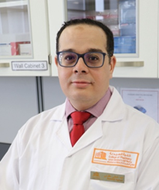

Prof. Abdelali Agouni is a Professor of Pharmacology. He previously served as the Post-Award Manager at the office of the vice president for research (February 2021 – February 2024). He is the founding graduate studies coordinator at the College of Pharmacy at Qatar University (2018 – 2022), and he established the first Ph.D. program in pharmaceutical sciences in the state of Qatar. Dr. Agouni graduated with a BSc (Biochemistry) in 2003 an MSc (Pharmacology) in 2005 from the University Louis Pasteur of Strasbourg (France) and a Ph.D. in clinical and experimental Pharmacology from the University of Angers (France) in 2008. After graduating with his Ph.D., he joined the University of Aberdeen (Scotland) in 2009 as a post-doctoral research fellow at the School of Biological Sciences. In October 2011, he moved to the University of Surrey as a tenured Assistant Professor of cardiovascular biology within the Faculty of Health and Medical Sciences. In 2015, he joined the College of Pharmacy of Qatar University as an assistant professor of pharmacology, and then in 2017, he was promoted to the rank of associate professor. Subsequently, in 2022, he was promoted to the rank of Professor.
Dr. Agouni is an expert in cardiovascular and metabolic functions phenotyping (83 peer-reviewed publications to date an h-index of 31 and a total number of citations of 3,448) and a strong experience in investigating intracellular signaling pathways using both cellular and transgenic animal models of obesity, diabetes, and cardiovascular disease. The major focus of his research to date has been to gain a better understanding of the mechanisms linking obesity and diabetes to cardiovascular complications such as hypertension and atherosclerosis and develop new tools to prevent and reverse these co-morbidities. Dr. Agouni has established expertise in intercellular communication and the role of circulating microvesicles as biomarkers and vectors of metabolic and cardiovascular dysfunctions. Dr. Agouni has expertise in collaborating on large clinical studies and currently contributes to a major clinical study on stroke with Hamad General Hospital (Qatar), a project funded by Qatar University and Qatar National Research Fund. In addition, he is actively involved in drug discovery endeavors using an in-silico-guided approach for the identification of novel small molecules for diabetes and cancer. He secured several research grants from QNRF, Qatar University, and HMC for the development of novel biomarkers and therapies for diabetes, cardiovascular disease, and cancer. Dr. Agouni has successfully managed several competitive research grants involving teams inside and outside Qatar. He is currently a senior investigator on multiple active grants with a cumulative research income of over $2.5 million. Dr. Agouni has successfully supervised several undergraduate, MSc, and PhD students.
The scientific community recognizes Dr. Agouni’s expertise through invitations to the editorial boards of several journals. His expertise in metabolic and cardiovascular research fields is recognized both nationally and internationally, and he regularly reviews major grant proposals for national and international funding bodies and agencies such as Medical Research Council UK, Diabetes UK, British Heart Foundation, Swiss Science Foundation, Dutch Heart Foundation, and the Dutch organization for health & healthcare innovation. In addition, he routinely acts as an ad hoc reviewer for several international journals. Dr. Agouni has strong experience as an educator and has significant experience in both undergraduate and postgraduate teaching. His teaching quality is internationally recognised and in 2013 he achieved the status Fellow of the Higher Education Academy (FHEA).

PubMed: https://pubmed.ncbi.nlm.nih.gov/?term=agouni+a&sort=date
Google Scholar: https://goo.gl/CdVTSk
https://scholar.google.co.uk/citations?user=L_SGjuwAAAAJ&hl=en

Dr. Mohamed Elrayess
Academic degrees BSc, PhD
Academic rank Associate Professor
College Pharmacy, QU Health
Address I03 Building, Qatar University
E-mail m.elrayess@qu.edu.qa

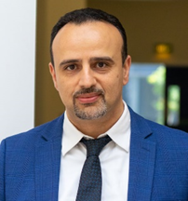

Dr Mohamed Elrayess has a PhD in cardiovascular genetics from University College London, United Kingdom, in 2003. He served as a postdoctoral fellow at the Cardiovascular Medicine unit at University College London (2003-2004) where he investigated stem cell therapy in cardiovascular disease, then spent 8 years (2004-2012) as a scientist at Eisai, a top international pharmaceutical company, where he developed skills in drug discovery and development, mainly focusing on stem cell therapy in neurodegenerative disease. He then spent the following 7 years (2012-2019) working as a senior scientist at Anti-Doping Lab Qatar, an international testing laboratory for doping abuse in elite athletes, using various OMICS approaches for the identification of novel biomarkers of insulin resistance and diabetes and investigating genetics and metabolomics of elite athletes.

Dr Elrayess has joined Qatar University in 2019 as a research assistant then associate professor at the Biomedical Research Center where he leads the OMICS research group. His research is focused on investigating novel therapeutic targets in insulin resistance and diabetes as well as sports OMICS research. He has over 60 publications, supervised 3 PhD students and a number of MSc students and raised more than 3 million USD research funding. He is currently the director of basic research at QU Health cluster.

PubMed: https://pubmed.ncbi.nlm.nih.gov/?sort=date&term=Elrayess+MA&cauthor_id=36005643
Google Scholar: https://scholar.google.com/citations?user=tiOCu6UAAAAJ&hl=en

Nizar Ali Ahmed Al-Shar'i
Professor of Medicinal Chemistry and Computer-Aided Drug Design
Academic degrees BSc, MSc, PhD
Academic rank: Professor
College Pharmacy, QU Health
Address I03 Building, Qatar University
E-mail: n.alshari@qu.edu.qa
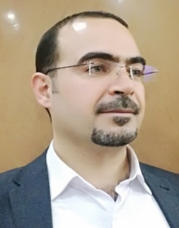

Dr. Nizar Al-Shar’i is a professor of Medicinal Chemistry and Drug Design in the Department of Pharmaceutical Sciences at the College of Pharmacy, Qatar University (QU), Doha, Qatar. He earned a BS Pharm degree in 2001 and an MPharm in medicinal Chemistry in 2007 from the Faculty of Pharmacy, Jordan University of Science and technology (JUST), Irbid, Jordan. In 2013, he graduated from Strathclyde Institute of Pharmacy and Biomedical Sciences (SIPBS), University of Strathclyde, Glasgow, UK, with a PhD in Medicinal Chemistry and Computer-Aided Drug Design, and then he joined the Faculty of Pharmacy at JUST as a full-time lecturer. In April 2013, he was promoted to assistant professor, then to associate professor in June 2018, and in April 2023 he was promoted to full professor.
During that time, he was appointed to many administrative positions. He started as an assistant dean for postgraduate and quality assurance affairs, then as a chairperson for the department of medicinal chemistry and pharmacognosy, and finally as a vice dean for accreditation and quality assurance where he was in charge of the ACPE accreditation file. Meanwhile, he also chaired many institutional committees such as assessment committee, accreditation and quality assurance committee, and participated in many committees such as strategic planning, scientific research, postgraduate studies, to name a few.
In terms of research, he interested in drug discovery via applying Computer-Aided Drug Design (CADD) methods, and Molecular Dynamics (MD) Simulation. He also published many articles (over 50) in peer-reviewed international indexed journals. He has a firm believe that the integration of experimental and theoretical approaches, particularly through CADD and molecular modeling, provides unparalleled insights into the systems under investigation which are pivotal for advancing drug discovery

PubMed: https://pubmed.ncbi.nlm.nih.gov/?term=Al-Shar%27i+NA&cauthor_id=38925196&size=200
Google Scholar: https://scholar.google.com/citations?user=tL53ex0AAAAJ&hl=en

Zaheer-Ud-Din Babar
Professor of Clinical Pharmacy and Practice
Academic degrees BSc, MSc and PhD
Academic rank: Professor
College Pharmacy, QU Health
Address I03 Building, Qatar University
E-mail: z.barbar@qu.edu.qa

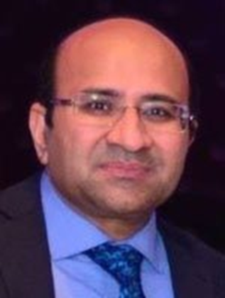

Professor Zaheer Babar is the Professor of Clinical Pharmacy and Practice at the College of Pharmacy, Qatar University, and a Visiting Professor at the Department of Pharmacy, University of Huddersfield, United Kingdom. His previous academic positions include Professor in Medicines and Healthcare and Director of Pharmaceutical Policy and Practice Research Centre, University of Huddersfield, UK (2017-2023), and Head of Pharmacy Practice, University of Auckland, New Zealand (2007-2016). He is widely acclaimed for his work in policy and practice, particularly in the areas of quality medicine use, medicine access, and pricing.
He has authored over 330 papers and is regarded as the leading researcher in the “pharmacy practice research category” in both Google and Scopus rankings. His publications have appeared in highly respected journals such as PLoS Medicine and The Lancet.
He has served as a consultant for various organizations, including the World Health Organization, Royal Pharmaceutical Society, United Nations Development Programme (UNDP), Health Action International, MSH, International Union Against Tuberculosis and Lung Disease, World Bank, European Union, International Pharmaceutical Federation (FIP), and the Pharmaceutical Management Agency of New Zealand.
Professor Babar’s edited works include “Economic Evaluation of Pharmacy Services,” “Pharmaceutical Prices in the 21st Century,” “Pharmaceutical Policies in Countries with Developing Healthcare Systems,” “Global Pharmaceutical Policy,” “Access to High-Cost Medicines,” “Pharmacy Practice Research Methods,” “Pharmacy Practice Research Case Studies,” and “Encyclopedia of Pharmacy Practice and Clinical Pharmacy.” His most recent publication is “Encyclopedia of Evidence in Pharmaceutical Public Health and Health Services Research in Pharmacy.”
He is the founding editor-in-chief of the Journal of Pharmaceutical Policy and Practice, a high-impact publication providing evidence-based insights and recommendations for policymakers, practitioners, and researchers. He is passionate about advancing the quality, equity, and sustainability of healthcare systems and improving health outcomes for people around the world. If you wish to contact Professor Babar, you can reach him at z.babar@qu.edu.qa

Scopus: https://www.scopus.com/authid/detail.uri?authorId=57222325633

Banan Abdulrzaq S Mukhalalati
Academic degrees BSc, MBA, PhD
Academic rank: Associate Professor
College Pharmacy, QU Health
Address I03 Building, Qatar University
E-mail: banan.m@qu.edu.qa

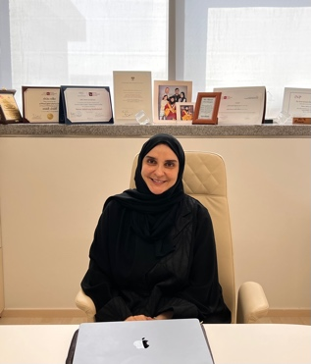

Dr. Mukhalalati is an Associate Professor in the Clinical Pharmacy and Practice Department in the College of Pharmacy at Qatar University and the Director of Integrated Learning Office in the QU Health. Dr Mukhalalati received her BSc in Pharmacy from King Saud University in Saudi Arabia, and her MBA from Qatar University, before doing her PhD in the University of Bath in UK. Dr. Mukhalalati joined QU as a Founding Assistant Dean for Faculty and Student Affairs in 2009. Dr Mukhalalati has been appointed by FIP as a Global Lead for the 3rd FIP Development Goal “Quality Assurance” in 2019. Dr Mukhalalati is also an active member of the Academic Pharmacy section in FIP. In 2020, Dr Mukhalalati graduated from the Executive Leadership Program by Qatar Leadership Center and recently she graduated from Qatar University Teaching in Higher Education Fellowship in collaboration with Harvard Graduate School of Education at Harvard University

Dr. Mukhalalati’s research interests are in the areas of learning theories, health profession education, preceptors’ professional development, cultural competence, capacity building, and disaster management. She has established research collaborations with prestigious institutions both locally and globally, has more than 25 publications in the areas of health profession education and research, and has been involved in supervising MSc students. She has received more than 15 intramural and extramural research funding (from QU and QNRF) as a lead principal investigator. She has also presented more than 35research abstracts as posters, and podium presentations in local, regional, and international conferences, symposia, and workshops.

Google Scholar: https://scholar.google.com/citations?user=j6K3pc4AAAAJ&hl=en

ORCID: https://orcid.org/0000-0002-0049-8879

Sowndramalingam Sankaralingam
Academic degrees: BSc, MSc and PhD
Academic rank : Associate Professor
College Pharmacy, QU Health
Address I03 Building, Qatar University
E-mail: sownd@qu.edu.qa

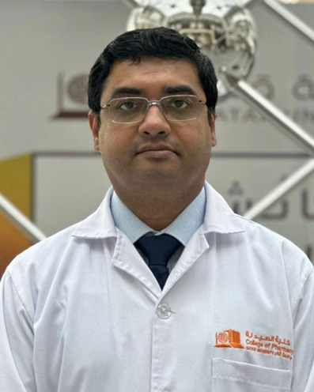

Dr. Sownd Sankaralingam received his MBBS degree from the Tamil Nadu Dr. M.G.R Medical University, Chennai, India in 2002. He completed an MSc in Pharmacology from the University of Saskatchewan, Canada in 2004 with thesis on the role of 20-HETE in salt-sensitive hypertension. Subsequently, he obtained his PhD degree from the Department of Physiology, University of Alberta, Canada in 2009 for his thesis on the mechanisms of endothelial cell oxidative stress in preeclampsia. During this time, he received studentships from the Alberta Heritage Foundation for Medical Research and the Heart and Stroke Foundation of Canada. As an Alberta Innovates Health Solutions funded post-doctoral fellow (2011-2014) at the University of Alberta he investigated the alterations in cardiac energetics (energy metabolism) in cardiac hypertrophy and heart failure. Subsequently, he completed a clinical research fellowship in the Department of Medicine with focus on hypertension.

His research focuses on pharmacist-involved care in cardiovascular diseases including hypertension and diabetes. He is currently investigating validation status of blood pressure monitoring devices sold in community pharmacies and pharmacist preparedness to be involved in home blood pressure monitoring. His research interests include use of digital technology for cardiovascular risk management.

Dr. Sownd has published more than 25 peer-reviewed articles, and has presented his work at several national and international conferences. His research is funded by grants from Qatar University and QNRF.

Hesham Al-Sallami
Academic degrees: BSc, MSc and PhD
Academic rank: Associate Professor
College Pharmacy, QU Health
Address I03 Building, Qatar University
E-mail: H.Al-sallami@qu.edu.qa

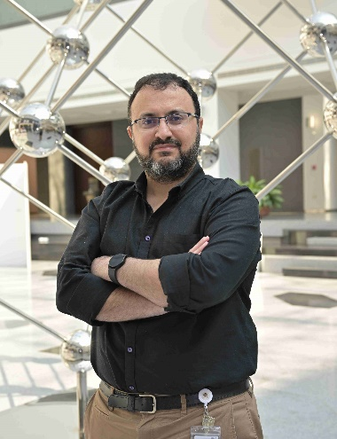

Hesham Al-Sallami is an associate professor of clinical pharmacy practice. He joined the college in 2024 and teaches in the undergraduate, PharmD, and master’s pharmacy programs.
Originally from Yemen, I trained as a clinical pharmacist in New Zealand and obtained a master’s in clinical pharmacy practice from the University of Otago. I have 16 years’ experience in clinical pharmacy/pharmacotherapeutics teaching, practice, and research.
I hold a PhD (University of Otago) in quantitative clinical pharmacology and pharmacometrics. My research interests include drug dose individualization in special populations, with a focus on pediatrics and obesity. My work involves the development of dosing guidelines and dose calculation tools for medicine dosing in special populations.
I have a particular interest in the pharmacotherapeutics of cardiovascular, coagulation, and endocrine diseases. This interest stems from my research expertise and experience in drug dosing related to these conditions. I have also developed, taught, assessed, and evaluated topics in clinical pharmacokinetics, and I have a particular interest in clinical PK modelling and therapeutic drug monitoring.
In terms of service, I was involved in the development of a modular BPharm curriculum and was a member of the undergraduate programs, curriculum review, postgraduate programmes, research, and admission committees. I held the role of associate dean in pharmacy practice and admissions and I have experience in aligning student selection and admissions with the needs of the pharmacy health workforce in New Zealand.
My other notable service role is being a clinical pharmacology expert advisor to healthcare regulatory agencies. The role involved reviewing dose selection and dosing in special populations of new drugs entering the Oceania markets.

PubMed: https://pubmed.ncbi.nlm.nih.gov/?term=Hesham+Al-Sallami+&sort=pubdate&size=200
Google Scholar: https://scholar.google.co.nz/citations?user=nEEJadgAAAAJ&hl=en

