PhD Potential Supervisors College of Medicine

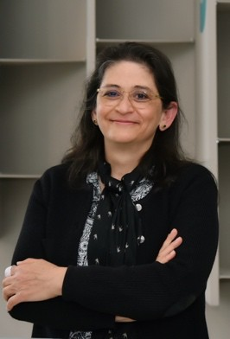
Professor Aida Habib,
Professor of Pharmacology College of Medicine
P.O. Box 2713 Doha, Qatar
Email: Aida.Habib@qu.edu.qa

Dr. Aida Habib is a full professor of Pharmacology at the College of Medicine, Qatar University. Dr. Aida Habib obtained her MS in Molecular and Cellular Biology-
Immunology from Université de Pierre et Marie Curie, Paris, France, and her Ph.D. in Molecular and Cellular Biology of Vessels and Platelets-coagulation from Université Paris 7 (now Université de Paris), working on arachidonic acid and cyclooxygenase-2 in endothelial cells.

After a post-doctoral fellowship at the University of Pennsylvania, Philadelphia in the group of Garret FitzGerald, she was appointed as a senior researcher at the CNRS in Paris, France, conducting her research on the regulation of cyclooxygenases and the signaling of the thromboxane receptors in the vascular and inflammatory cells. In 2002, she joined the faculty of Medicine at the American University of Beirut as an associate professor of Biochemistry.

She was promoted to professor in 2008. During this time, she was a visiting researcher in the group « Inflammatory responses in chronic liver diseases », led by Dr. Sophie Lotersztajn at the Center for Research on Inflammation (CRI, INSERM U1149), Paris, France. Dr. Aida Habib is an internationally recognized researcher working on prostanoids and the arachidonic acid pathway in inflammation vascular biology.

She has also contributed to important studies on liver fibrosis. She carries out translational research on inflammation and liver pathophysiology through projects covering molecular and cellular aspects as well as animal models. Her research aims for a better understanding of the mechanisms of inflammatory disease and liver failure. The focus is on the identification of targets in macrophages that limit inflammation.

Dr. Aida Habib is the recipient of the Bronze Medal for research from the CNRS in France. She published more than 80 papers in peer-reviewed journals (Google scholar h-index 41, ˃ 6500 citations).

Google scholar: htps://scholar.google.com/citations?user=521MHrcAAAAJ&hl=en

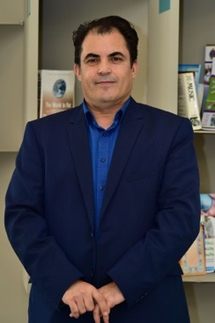
Professor Laiche Djouhri Professor of Physiology College of Medicine
P.O. Box 2713 Doha, Qatar
Email: ldjouhri@qu.edu.qa

My research is focussed on understanding of the processing of nociceptive “pain” information and in the peripheral mechanisms underlying hyperexcitability of dorsal root ganglion (DRG) neurons, and hypersensitivity associated with chronic inflammatory and neuropathic pain (NP), major health problems. My current research interests include the role of the immune and nervous systems, and ion channels (e.g. KCNQ/Kv7, and HCN channels) in spontaneous activity in DRG neurons that that drives chronic inflammatory and neuropathic pain. I have been using the following animal (rat) models of chronic pain and approaches:

Animal models of chronic pain
- CFA (Complete Freund’s adjuvant) model of chronic inflammatory pain
- SNL (spinal nerve ligation) model of neuropathic pain
- STZ (Streptozotocin) model of diabetes-induced neuropathic pain
- Paclitaxel model of chemotherapy-induced neuropathic pain

Approaches/techniques
- In vivo single electrode voltage clamp (SEVC) recordings in anaesthetized rats.
- In vivo voltage recordings in anaesthetized rats coupled with dye-injection and immunocytochemistry
- Immunohistochemistry of whole DRGs.
- Pharmacological and behavioural studies to examine effects of modulating ion channels (e.g. HCN and Kv7) and proinflammatory mediators (e.g. cytokines and NGF) on the excitability of nociceptors and pain hypersensitivity in the aforementioned animal models of chronic pain.

Google Scholar: https://scholar.google.com/citations?user=bZOxBqEAAAAJ&hl=en

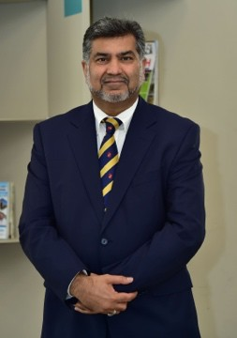
Professor Saghir Akhtar Professor of pharmacology College of Medicine
P.O. Box 2713 Doha, Qatar s.akhtar@qu.edu.qa

Saghir Akhtar is currently Professor of Pharmacology at the College of Medicine,
Qatar University and Editor-in-Chief of the Journal of Drug Targeting. He was previously Professor of Drug Delivery in the Welsh School of Pharmacy and Director for the Centre for Genome-based Therapeutics, Cardiff University, UK and more recently as Professor of Molecular Pharmacology at the Faculty of Medicine, Kuwait University,

Prof Akhtar obtained a First Class honors degree in Pharmacy from the Leicester School of Pharmacy (UK) and his Doctor of Philosophy degree from the University of Bath in the UK. He then undertook a post-doctoral fellowship at the University of North Carolina Medical School at Chapel Hill, North Carolina, USA and began his independent academic career at Aston University (Birmingham, UK), firstly as lecturer and then as Reader in Pharmaceutical Sciences. He was also a visiting fellow in the Department of Biochemistry, Oxford University, UK (with Professor Ed Southern).He has published well over 120 full peer-reviewed research articles in leading journals and holds several patents that have emanated from his research in medical and health sciences. In addition, Prof Akhtar has trained and mentored many research students and post-doctoral fellows and serves the research community through his roles as Editor-in-Chief, Associate Editor and Editorial Board member of several peer-reviewed research journals. Prof Akhtar has also served as an invited organizer and/or keynote speaker at numerous international conferences.

Professor Akhtar’s research and teaching has been recognized internationally with the award of several prestigious prizes including the Lilly Prize, the Pfizer Academic Award, the British Pharmaceutical Conference Science Medal, the Controlled Release Society (USA) Young Investigator Research Achievement Award, the Kappa Society Science Award and the Fazlur Rahman Khan Award for Excellence in Engineering, Science and Technology (London, UK). In 2020, he also received one of the top two best teacher awards from students at the College of Medicine at Qatar University. In addition to his research and teaching, Prof Akhtar has previously held several senior administrative positions including as Head of Department and Director of Postgraduate studies. He has also served as a curriculum advisor and external examiner for several international universities.

Research interests

Professor Akhtar conducts basic and translational research in the fields of cancer and diabetes. Current research interests include studying a) the molecular pharmacology and signal transduction pathways involved in breast and brain cancers, diabetes and/or hypertension-induced cardiovascular dysfunction; b) the nanotoxicology and biological activity of novel drug delivery systems especially for gene silencing nucleic acid-based nanomedicines and c) the impact of pharmacotherapy on clinical outcomes in COVID-19 patients.

Google Scholar: https://scholar.google.com/citations?hl=en&user=vJQ51RMAAAAJ&view_op=list_works

Google Scholar: https://scholar.google.com/citations?hl=en&user=vJQ51RMAAAAJ&view_op=list_works

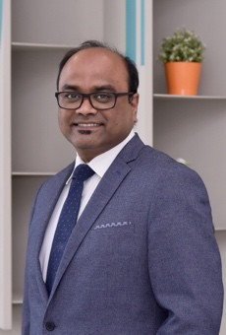
Professor Giridhara R Babu
Professor, Department of Population Medicine, College of Medicine, Qatar University
Po Box: 2713 Doha, Qatar
Phone +974 4403 7856
Email: gbabu@qu.edu.qa

Giridhara R Babu has a medical degree (MBBS) from Kasturba medical college
Manipal and has completed MPH and PhD from UCLA (University of California Los Angeles). Giridhara is a member of the Faculty of Public Health (UK) and a chartered member of the National Board of Public Health Examiners (USA). He has two decades of experience in public health research, practice and academics. He began his career at the Center for Community Medicine of the All India Institute of Medical Sciences, New Delhi as a Junior Resident. Next, he worked with World Health Organization where he led the efforts in stopping polio transmission in the state of Karnataka. He initiated advocacy for Measles surveillance in Karnataka leading to constitution of Multi Year Plan (MYP) for Measles elimination in India. He is awarded intermediate and now the senior fellowship of Wellcome Trust-DBT India Alliance to start and expand cohort study. The cohort is named as MAASTHI (Maternal Antecedents of Adiposity Studying the Transgenerational role of Hyperglycemia and Insulin). He is also co-PI of 1 million GBP Newton Fund titled GUIDES to examine the role of educational intervention in screening and management of Gestational Diabetes Mellitus.

He is awarded Wellcome Trust Team Science grant of 1.3 million USD, where he will be leading a consortium of 18 investigators across 6 premiere public health institutions. This research program titled Nutritional, psychosocial and environmental determinants of neurodevelopment and child mental health (COINCIDE) aims to evaluate how multiple factors in a child’s immediate environment impact their development in the first decade of their life starting from pregnancy.

Giridhara has over 100 papers published in national and international high impact journals. He has served on several national and international committees. Some of them include Lancet Commission Task force on COVID19, ICMR National Task Force for COVID-I9 and the Technical Analysis Committee of the Government of Karnataka. He is the regional representative for LMICs on the DoHaD international society.

Research Interests: Primary Prevention of Non-Communicable diseases, Obesity, Type 2 Diabetes Mellitus, Global health, Health Policy, Life course Epidemiology.

Google Scholar Profile: https://scholar.google.com/citations?user=2d1vYIgAAAAJ&hl=en

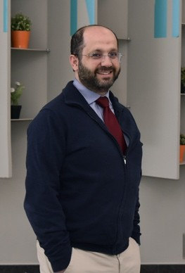
Dr. Ali H. Eid
Associate professor of Pharmacology College of Medicine, Qatar University Po Box: 2713
Doha, Qatar
Phone: +974 4403 7893
College of medicine Email: ali.eid@qu.edu.qa

Dr. Eid obtained his Ph.D. in Biomedical Sciences from the Ohio State University where he conducted his doctoral (and later postdoctoral) research at the Davis Heart and Lung Research Institute. He had previously obtained his MSc from Bowling Green State University, USA and his BSc from the American University of Beirut.

The main research focus in Dr. Eid's laboratory is the molecular and cellular pharmacology that culminates in drug discovery. Dr. Eid has leveraged his training and experience in cellular and molecular biology to pursue research questions related to alpha 2 adrenoceptors (α2-ARs) in the context of vascular disease. Specifically, the role of the neuronal (norepinephrine), humoral (epinephrine) and endocrine (estrogen and cortisol) factors that govern the function of vascular α2-ARs is of prime importance. Dr. Eid has set up a drug discovery program that screens, identifies and characterizes new drugs from natural and synthetic origins. For the natural sources, his team first selected several plants with established medicinal value in the culture. To this end, Dr. Eid and his students published several papers in highly reputable Q1 journals; many of these papers were invited papers, indicative of the team’s sought expertise. As an example of the synthetic chemistry element, Dr. Eid and his medicinal chemistry collaborators have identified a few compounds that are more efficacious and more potent than 5-fluouracil, a standard anti-cancer drug. Importantly, these newly discovered compounds elicit their anticancer effects even in cancer cells that are resistant to current treatment. Another aspect of Dr. Eid’s research tackles the molecular mechanisms implicated in adrenergic signaling, expression and trafficking.

Dr. Eid has garnered several teaching and research awards, has secured many national and international research awards, and serves as an editor for many Q1 journals. Dr. Eid enjoys teaching his students the art of research and scientific writing. Indeed, his students have a strong record in publishing in top Q1 jounals. He has published over 170 peer-reviewed papers in highly reputable journals. His h-index is currently 36, with a steady increase in citations as per the following scholar link.

Google scholar link: https://scholar.google.com/citations?user=Pj2rOPkAAAAJ&hl=en

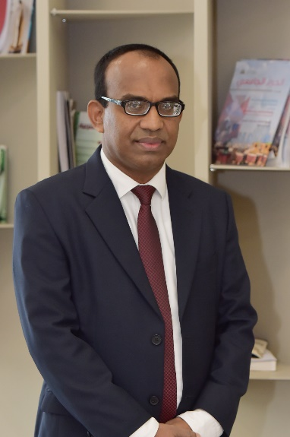
Dr. Ajith Sominanda,
Associate Professor of Anatomy and Basic Medical Sciences
College of Medicine, Qatar University
P.O. Box 2713
Doha, Qatar
Email: ajithsomi@qu.edu.qa
+974 4403 7876 / 33808329

Education and academia:
- Graduated in Bachelor of Medicine and Surgery (MBBS) at Faculty of Medicine (FOM), University of Peradeniya-Sri Lanka (UOP). For post-graduation, reading for Master of Philosophy (MPhil) in Anatomy and Cell Biology (2006) at FOM-UOP, and reading for Ph.D. in Neurology/Neuroimmunology at Karolinska Institute, Sweden (2008) followed by the postdoctoral fellowship (awarded by European Neurological Societies) at University hospital Dusseldorf, Germany (2009-10).
- Completed the residency in four major clinical specialties, followed by working as a physician in internal medicine and neurology at General Hospital (teaching) Peradeniya Sri Lanka (1998-2000).
- Teaching, Examination, curricular development, evaluation and monitoring, course coordination for undergraduate medical, allied health sciences and postgraduate MD-Surgery, ophthalmology, and Gyn-Obs, in the capacities of a lecturer, senior lecturer, and aa a professor in anatomy (major) (2001-2020). Teacher and examiner in immunology for undergraduate medicine (2010-2020).
Research:
- Visiting researcher to MRC/University of Oxford, UK to study genomic instability in irradiated fibroblast cell lines with confocal and electron microscopy.
- Histo-morphometric studies on human trophoblastic tissues in normal and pathological pregnancies.
- During the Ph.D. and postdoctoral period, studied Anti-drug antibody development in multiple sclerosis (MS), innovation and optimization of novel bioassays to detect neutralizing antibodies, effects on natural cytokines and immune-gene expression pattern in antibody-antigen interaction with macrophages.
- With the NRC grant (Sri Lanka) as a principal investigator, studied Clinical and immunological characterization of MS and rheumatoid arthritis in Sri Lanka with an outcome of publications, MPhil degrees, validation and optimization of clinical assessment protocol and, cytokine profiling with disease modifying drugs.
- Miscellaneous research collaborations to study biomechanical and kinesiology studies in neck movements, cluster headache and cytokine profiles and diabetes.
- Current research at QU:
  - Cytokines in TIM (Tumor immune microenvironment) in invasive human cancers
  - Biomechanical movement and gait analysis in e-scooter scenario in collaboration with civil engineering department QU.
  - Medical education studies in collaboration with FOM, UOP-Sri Lanka.
Google scholar: https://scholar.google.com/citations?hl=en&user=pJSCyQIAAAAJ

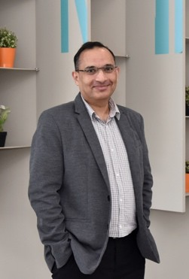
Dr. Asad Zeidan
Associate professor of Physiology College of Medicine, Qatar University Po Box: 2713
Doha, Qatar College of medicine
Email: a.zeidan@qu.edu.qa

Dr. Asad Zeidan is an Associate Professor of physiology in the College of Medicine at the University of Qatar. He received fellowships for graduate study in vascular
physiology from Swedish Institute and Faculty of Medicine at Lund University in Lund, Sweden. In 2003 he received his Ph.D. degree in vascular physiology at Lund University, Sweden. His Ph.D. study focused on stretch-dependent growth and remodeling in vascular smooth muscle cells (VSMC). The major goal of his Ph.D. research was to identify the signals behind mechanical stretch-induced growth and differentiation marker proteins in VSMC. In January 2004, Dr. Zeidan moved to London, Ontario, Canada, for his postdoctoral studies in the department of physiology and pharmacology, Faculty of Medicine at University of Western Ontario. His research involved studies of the molecular mechanisms underlying hypertrophic effect of the obesity associated protein leptin in vascular and cardiac tissues. In December 2009, Dr. Zeidan accepted a faculty position in the Cardiovascular Research Institute at the University of Rochester, New York. During his stay, he received the highly competitive and prestigious Scientist Development Grant (#10SDG4250012 success rate: 8.3%) from the American Heart Association (AHA), which is reserved for promising young scientists. In 2011, Dr. Zeidan joined the Department of Anatomy, Cell Biology, and Physiology at American University of Beirut (AUB) as an Assistant Professor of Physiology. At the same time, he established his own research profile working on hypertension and obesity. His main research focus was on studying the relationship between obesity-associated proteins (adiponectin and leptin), hypertension, and mechanotransduction signaling in VSMCs/endothelial cells in vitro and in vivo. His projects utilize his experience and knowledge from both his graduate and postdoctoral training in vascular and cardiac research in order to study, in-depth, novel molecular mechanisms in the regulation of cardiovascular function in health and disease. In 2012, he received the Talal Zein award in Hypertension and Cardiovascular Prevention from the European Society of Hypertension. He was later awarded a travel research fellowship from the Royal College of Physicians (Daniel Turnberg Travel Fellowships). Dr. Asad has around 60 peer-reviewed publications and book chapters in highly ranked scientific journals and his H- Index stands right now at 31.

His principal research activities focus on:

- Characterizing the mechanisms by which VSMC in the vascular wall sense changes in blood pressure and modulate vessel size and tone. Using blood vessels organ culture, models of hypertension (in vivo) and cardio-vascular-proteomics platform; molecular signalling that are involved in hypertension-induced VSMC remodelling are being investigated. The goal is to identify novel biomechanical sensing molecules.
- Understanding of the mechanisms of the obesity associated proteins (such as leptin and adiponectin)- and diabetes-induced cardiac and vascular remodelling.
- Design and validation of a model for In Vitro investigation of shear stress and its role in atherosclerosis.

Google Scholar: https://scholar.google.com/citations?user=WleqHWoAAAAJ&hl=en

Dr. Ammar Boudaka  Associate Professor of Physiology  College of Medicine, Qatar University  P.O. Box 2713  Doha, Qatar  Phone: +974 4403 7877  Email: aboudaka@qu.edu.qa | 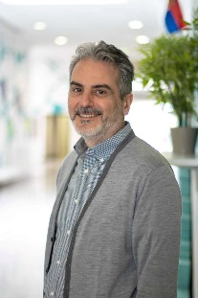

Dr. Ammar Boudaka is an Associate Professor of Physiology in the College of Medicine at Qatar University. He earned his Bachelor's degree in Medicine and Surgery (MBBCh) form the Faculty of Medicine, Tripoli University (formerly named Alfateh University) in Libya (1997), where he ranked first among his peers. After graduation, he worked as a general practitioner for five years in different government and private hospitals and clinics before moving to Japan to obtain his PhD in Physiology (2007). He did his postdoctoral fellowships in Germany (DFG scholarship, 2007-2008) and Japan (JSPS scholarship, 2008-2010). In February 2010, he left the National Institute for Physiological Sciences in Japan and moved to Oman where he worked as an assistant professor for 2 years at University of Nizwa (UoN) before moving to Sultan Qaboos University (SQU) where he worked as an assistant professor and then as associate professor for the last 10 years. In August 2022, he joined Qatar University to work as an associate professor in Physiology at the College of Medicine.
Throughout his academic career he was extensively involved in teaching physiology at different levels (undergraduate and postgraduate) as part of the multidisciplinary integrated MD curriculum, as well as teaching physiology to dentistry, pharmacy, nursing and biotechnology students. He is the associate editor and scientific abstract translator (English to Arabic) of Sultan Qaboos University Medical Journal (SQUMJ), and a reviewer in many field-related scientific international journals. Moreover, he is an AHA certified BLS instructor delivering BLS provider course to MD students before their transition to phase 3 and an active member of different committees at the department and college levels.
His research interest is mainly on the functional role of Transient receptor potential (TRP) channels, a superfamily of cation permeable ion channels that are abundantly expressed in the body and integrate numerous physiological processes. He specifically focuses on the functional role of TRPV4, a non-selective multimodal cation channel, in different organ systems and its role in the pathogensis of different disease conditions, such as hypertension, diabetes mellitus, peptic ulcer, renal failure and osteoporosis, using murine models of these diseases and employing different in vivo and in vitro experimental approaches.
Google scholar: https://scholar.google.com/citations?user=tARNh44AAAAJ&hl=en

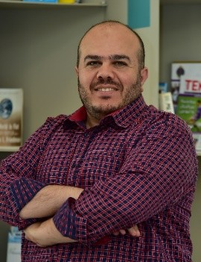
Dr. Ayman Mustafa
Associate professor of Anatomy College of Medicine, Qatar University Po Box: 2713
Doha, Qatar Phone: +974 4403
College of medicine
Email: amustafa@qu.edu.qa

Dr. Ayman Mustafa has earned his PhD in Anatomy and neurobiology from University of Kentucky USA in 2010. Since then, he has been teaching anatomical sciences to medical students in Jordan and Qatar. Dr Ayman original line of research is to study the role of oxidative stress in central nervous system injury. In addition to that, Dr Ayman is interested in studying oxidative stress in other biological and experimental systems including isolated smooth muscle contractility, cancer cell lines and others. Another line of research that Dr Ayman is currently pursuing is human surgical and radiologic anatomy and its application in forensic sciences. He conducted several studies in this field and published them in reputable international journals. Moreover, Dr Ayman is conducting research projects in medical education and research bioethics.

Google Scholar: https://scholar.google.com/citations?user=tRB7zGoAAAAJ&hl=en

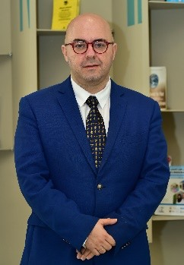
Dr. Michail Nomikos
Associate professor of Biochemistry College of Medicine, Qatar University Po Box: 2713
Doha, Qatar Phone: +974 4403
Email: mnomikos@qu.edu.qa

Dr. Nomikos earned his B.Sc. in Biochemistry from the University of Liverpool (UK) in
2000; and his M.Sc. in Medical Genetics with Immunology from Brunel University (London, UK) in 2002. The same year, he was awarded a Ph.D. studentship from the School of Medicine to perform his Ph.D. studies at Cardiff University (UK). After completing his Ph.D., he joined the National Center for Scientific Research (N.C.S.R.) ‘Demokritos’ in Athens (Greece). In 2014, Dr. Nomikos was awarded a highly competitive Intra-European Marie Curie Fellowship from European Commission to perform his research and teaching duties in the School of Medicine at Cardiff University until 2016. In September 2016, he joined Qatar University as an Assistant Professor of Biochemistry in the College of Medicine. One of the main research interests of Dr. Nomikos revolves around understanding the cell signaling mechanisms and metabolism during mammalian fertilization and early embryonic development. Moreover, Dr. Nomikos uses multidisciplinary approaches to study the structure and function of proteins involved in various signaling cascades in cardiomyocytes in an effort to understand their role, as well as the role of their disease-causing variants (mutants), in the pathogenesis, predisposition and diagnosis of human cardiac disease (such as arrhythmias, cardiac hypertrophy and early onset cardiac death). Dr. Nomikos has over 40 peer-reviewed publications (as well as 2 book chapters) in highly ranked scientific journals. In 2013, Dr. Nomikos was awarded the prestigious ‘Fertility and Sterility Investigator Achievement Award’ by the American Society for Reproductive Medicine. More recently, Dr. Nomikos received the international "Outstanding Paper Award 2017" of the Asian Journal of Andrology (AJA), the official journal of The Asian Society of Andrology, in recognition of his publication ‘Is PAWP the "real" sperm factor?’ in AJA, for which Dr Nomikos was the primary and senior author. In 2019, Dr. Nomikos was promoted to Associate Professor and appointed as the Head of Research and Graduate studies in the College of Medicine at Qatar University.

Google Scholar: https://scholar.google.com/citations?user=H0sHU_QAAAAJ&hl=en

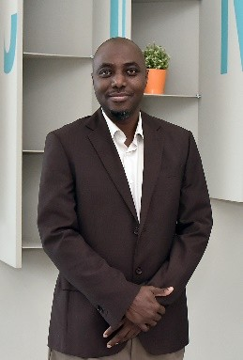
Dr. Mubarak Bidmos
Associate Professor of Anatomy College of Medicine
P.O. Box 2713 Doha, Qatar
Email: mbidmos@qu.edu.qa

Dr. Mubarak Bidmos received an MBBS (1996) from the University of Lagos, Nigeria,
and was awarded an MSc in Anatomy (2002) and a Ph.D. in Anatomy (2009) from the University of the Witwatersrand, South Africa. He was a lecturer at the University of the Witwatersrand, South Africa, a tutor at Canadian Memorial Chiropractic College, and an Assistant Professor of Anatomy at the University of Toronto, Canada. He has contributed significantly to the undergraduate training of medical students in South Africa and Canada. In addition, he has been heavily involved in the teaching of developmental anatomy, clinical anatomy, and forensic anthropology to postgraduate students.

Dr Mubarak has supervised/co-supervised postgraduate students from the University of the Witwatersrand (South Africa) and Western Sydney University (Australia) and is an Honorary Research Fellow with Human Variation and Identification Research Unit of the University of the Witwatersrand, South Africa. He has published more than 50 peer-reviewed research articles in internationally reputable journals and has served as a reviewer for a number of international journals including Forensic Science International published by Elsevier. He is recognized as one of the top 2% researchers in the field of Forensic Science in the world and is currently the Sectional Editor of the new addition to the Forensic Science International family, FSI: Reports.

Dr Bidmos main research interest is in the establishment and validation of standards for sex estimation and stature reconstruction for human identification. His current focus is in the use of data acquired from CT and MRI scans in the assessment of standards for human identification. He is also interested in studies that explore human anatomical variations of clinical significance.

Research Profile Links:
- Scopus: https://www.scopus.com/Mubarak Bidmos
- Google Scholar: https://scholar.google.com/Mubarak Bidmos
- ResearchGate: https://www.researchgate.net/profile/Mubarak_Bidmos

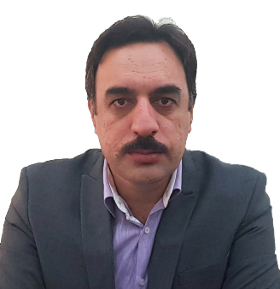
Dr. Muhammed Naseem Khan
Department of Population Medicine
College of Medicine
P.O. Box 2713
Doha, Qatar
Tel.: +974 4403 7839
Mobile:+97433056064
Email: naseem@qu.edu.qa

Dr. Muhammad Naseem Khan graduated with a Bachelor's degree in Medicine & Surgery (MBBS) from the University of Peshawar (Ayub Medical College, Abbottabad), Pakistan (2002). He did his Master of Science in Public Health (MSPH) from Quaid-i-Azam University (Health Services Academy), Islamabad, Pakistan, in 2009. Following his MSPH, he achieved the prestigious Higher Education Commission Ph.D., scholarship award in 2010. He completed his Ph.D. from the University of Liverpool, Faculty of Health & Life Sciences, United Kingdom in 2014. After completing his Ph.D. in 2014, Dr. Muhammad Naseem Khan was involved in collaborative research for his Post Doc from the University of Liverpool (2014-2016). This was two and a half year project to adapt and evaluate a community intervention to improve maternal mental health based on Cognitive Behavior Therapy (CBT) in post-conflict settings in Pakistan. He was the site Principal Investigator (PI) of this large research trial and led to peer-reviewed publications.
He taught Epidemiology, Biostatistics, and Research Methods for more than 8 years in Peshawar and Islamabad in Pakistan. He served as the Director Institute of Public Health & Social Sciences, Khyber Medical University, Peshawar for around 2 years. As an administrator, he worked very hard to improve the curriculum of the Master of Science of Public Health, Master in Health Research & MS Epidemiology and Biostatistics programs being taught at the Institute of Public Health & Social Sciences. He served Khyber Medical University for almost six years before moving to Islamabad to join his alma mater i.e. Health Services Academy, Islamabad, Pakistan as a Professor of Public Health. He also served as Chairman Curriculum Review Committee, and Member of the Syndicate and Academic Council at Health Services Academy Islamabad, Pakistan. In August 2022 he joined Qatar University as an Associate Professor in the Department of Population Medicine at the College of Medicine.

Research interests

Areas of his research interests include public mental health in general with a special focus of the maternal mental health on the women and their children. He also has research interests in nutritional supplementation and early childhood development. He has published around 30 papers in highly rated international journals. The pioneer Ph.D. student of Dr. Muhammad Naseem Khan has achieved his Ph.D. degree from the Institute of Public Health & Social Sciences Khyber Medical University Peshawar recently (2021) in Public health. During his supervision, his first Ph.D. student published four peer-reviewed publications with more than 20 impact factor. He is currently supervising four Ph.D. Students. Apart from these, he has supervised many postgraduate master's students in public health.

Google scholar: Muhammad Naseem Khan‬ - Google Scholar‬‬‬‬‬‬‬‬‬
Scopus: Khan, Muhammad Naseem - Author details - Scopus
ORCID: https://orcid.org/0000-0002-0484-0985

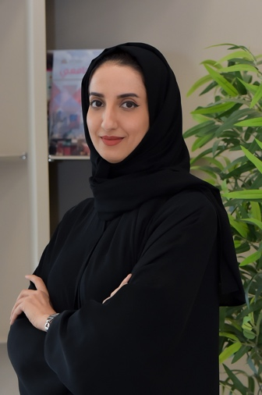
Dr. Hamda A. H. Al-Thawadi,
Associate Professor of Molecular Biology
College of Medicine
Qatar University

P.O. Box: 2713

Doha – Qatar
Tel: Office: (+974) 44037841
E-mail: halthawadi@qu.edu.qa

Dr. Hamda AL-Thawadi is an associate professor at College of Medicine, Qatar University. She obtained her bachelor’s degree in basic medicine from Arabian Gulf University, Kingdom of Bahrain (2003) and gained her Medical Degree from the same University in 2005. She has done her internship and residency in Hamad Medical Corporation, Doha, Qatar (2005-2008). She served as a research analyst at Qatar Foundation in 2009 working on evaluating research proposals for national and international organization and establishing partnership with different institutes in and outside Qatar. In 2011, Dr. Hamda joined the Program of Qatar Research Leadership-Science track, in which she has accomplished this program and graduated (2015). During this program, she worked on different projects related to molecular bases of ovarian cancer and stem cells in different laboratories in Paris such as Hôpital Hôtel-Dieu, Hôpital Saint-Antoine and Faculté de Médecine VI, Paris, France (2011-2013). Furthermore, she worked on different projects about ovarian and breast cancer in research laboratories of Weill Cornell Medical College, Doha, Qatar (2013-2015). She Obtained her PhD in Molecular Biology from Paris Saclay University, Paris, France, 2015. For the best PhD thesis, she has been awarded by H. H. Sh. Tamim Bin Hamad Al Thani the Scientific Excellence Award in 2017. She joined Qatar University at the inception of College of Medicine as an Assistant professor of Molecular Biology and served as an Acting Assistant Dean of Student Affairs of the College during 2019 and 2021. During this period, she has been awarded twice for the best teaching in the college.
She is Chair of Professionalism Committee in College of Medicine in addition to her active participation in several other committees at the level of college, QU-Health cluster, and university.

Meanwhile, her research work focusing on the role of HPV and EBV on several types of cancer in the Qatari population and the middle east.

Google Scholar: https://scholar.google.com/citations?view_op=new_profile&hl=ar

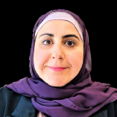
Dr. Salma Khaled
Associate Professor of Behavioral Sciences,
College of Medicine,
P.O. Box 2713 Doha, Qatar
Email: skhaled@qu.edu.qa

Dr. Salma M. Khaled is an Associate Professor at the Department of Population Medicine at the College of Medicine, Qatar University. Dr. Khaled graduated with a BSc in Psychology with Honors and a PhD in Community Health Sciences with specialization in Epidemiology from the University of Calgary, Alberta, Canada. Prior to her arrival in Qatar in 2014, Dr. Khaled worked for the Health Quality Council of Alberta as a senior analyst, and as a statistical consultant for Statistics Canada Survey Division and their Research Data Center in Calgary Alberta. Before working in the College of Medicine, Dr. Khaled worked at the Social and Economic Survey Institute (SESRI) at Qatar University. As part of her nine-year full-time appointment with the SESRI QU, she gained expertise in survey methodology and complex survey data analyses. Dr. Khaled lead many national and international collaborations aimed at measuring and understanding psychological phenomena and international diagnostic classifications in the context of Arabic-speaking populations of Qatar and the Middle East. She was the LPI on Qatar’s first national population-based mental health survey of 5000 Qatari and Arab residents conducted in collaboration with WHO and Harvard Medical School as part of the International Survey Initiative. Her research aims at bridging the gap between non-clinical and clinical perspectives of mental health and disease. She has published in many high impact journals like Lancet Psychiatry, Schizophrenia Bulletin, Psychological Medicine, International Journal of Social Psychiatry, and Schizophrenia Research.

Find my profile at College of Medicine: https://www.qu.edu.qa/medicine/faculty/bios#Salmak
Find my profile at Google scholar: https://scholar.google.com/citations?hl=en&user=OfI8nsMAAAAJ
Find my profile at Researchgate: https://www.researchgate.net/profile/Salma-Khaled-3/research

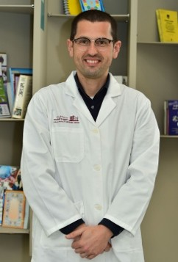
Dr. Semir Vranic,
Associate professor of Pathology
College of Medicine, Qatar University Po Box: 2713
Doha, Qatar
Phone: +974 4403 7873
Email: svranic@qu.edu.qa

Dr. Vranic graduated from the University of Sarajevo School Of Medicine in 2004. Completed residency program in pathology in 2011 and obtained PhD in pathology in 2012 at the Zagreb University School of Medicine. Worked as a consultant pathologist at the Department of Pathology, Clinical Center of the University of Sarajevo from 2012-2017. Joined the College of Medicine, Qatar University in September 2017. Did two post-doc fellowships (2008/2009 at the Creighton University School of Medicine, Omaha, Nebraska, USA; 2012/2013, Department of Medical Sciences, University of Turin, Italy). Additional training programs in breast pathology were completed at Nottingham City Hospital (UK) in 2008 and at Guy's and St. Thomas' NHS Foundation Trust/King's College London (2012). Was awarded as UICC Lifetime Fellow in 2010 and "The rising stars in pathology" by the Pathologist in 2016. Active in many professional and academic associations related to pathology and academic/scientific publishing (USCAP, European Society of Pathology, UICC, COPE, WAME, CSE). Actively involved in pathology education through establishment of the Bryan Warren School of Pathology (since 2007 annually) in collaboration with the British Division of the International Academy of Pathology (BDIAP) and Bosnian Turkish School of Cytopathology (since 2016 annually) in collaboration with the Turkish Division of IAP (TDIAP). Served as a president of national association of pathologists in Federation of Bosnia and Herzegovina (2015-2017). Has been section editor and editor-in-chief of Bosnian Journal of Basic Medical Sciences (since 2014), consulting editor in Breast Cancer: Targets and Therapy (2015-2019), academic editor in PLOS One (since 2018), associate editor in Cancer Cell International (2019-2020) and editorial board member of Annals of Translational Medicine (2017-2022). Has been serving as a peer-reviewer for >100 academic biomedical journals.

Research interests:

Has been actively involved in breast cancer, genitourinary and gynecologic cancer research as well as novel predictive biomarkers for precision medicine purposes (175 peer-reviewed publications + 110 abstracts for scientific conferences/meetings). Published one book (Review of Gynecologic and Breast Pathology, 2017) and six book chapters (two in Encyclopedia of Pathology, Springer 2018 and 2020, one in WHO Classification of Breast Tumors, IARC Lyon, 2019, one in book “Precision Medicine in Cancer Therapy” (2019), and one in book “Handook of Immunology and Cancer” (Springer, 2022, in press).

Google Scholar: https://scholar.google.com/citations?user=9FowakAAAAAJ&hl=en Scopus: https://www.scopus.com/authid/detail.uri?authorId=6506742049
ORCID: https://orcid.org/0000-0001-9743-7265

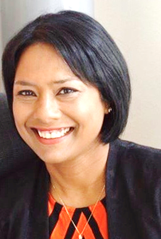
Dr. Shona Pedersen
Associate Professor of Biochemistry
College of Medicine, Qatar University
P.O. Box 2713
Doha, Qatar
Phone: +974 4403 7879/7742 5884
Email: spedersen@qu.edu.qa

Dr. Shona Pedersen graduated with honors from Natal University with a B.Sc. in Biomedical Science in 1992; and a M.Sc. in Medical Biochemistry from Pretoria University in 1998. In 2004, she was awarded a Ph.D. in Medical Biotechnology, Biochemistry, and Protein Engineering from the Faculty of Engineering and Science at Aalborg University, Denmark.

After completing her doctoral degree, she continued as a Senior Scientist (2004 –2021) at the Department of Clinical Biochemistry, Aalborg University Hospital, where she played a central role in initiating and developing the proteomics and metabolomics research laboratory. In 2007, she was also awarded an Associate Professor position from the Department of Clinical Medicine at Aalborg University, Denmark. In addition, Dr. Pedersen serves as a board member of the Clinical Cancer Research in Denmark and an Associate Editor for Molecular Signalling, a specialty section of Frontiers in Molecular Neuroscience. Dr. Pedersen joined Qatar University in August 2021 as an Associate Professor in Biochemistry at the School of Medicine, Department of Basic Medical Science. To date, Dr. Pedersen has published more than 60 scientific research papers and was awarded two patents for her discoveries. In addition, she has supervised and examined numerous undergraduate and master's students. Five Ph.D. students successfully completed their PhD under her supervision. Currently, Dr. Pedersen is leading the neuro-cardio networking group at Qatar University.

Dr. Pedersen's primary research focuses on discovering novel diagnostic and Predictive Protein and Metabolite biomarkers in disease through multi-omic techniques. Dr. Pedersen's research group has positioned itself to map the protein and metabolite diagnostic and predictive signatures in small cell lung cancer, multiple myeloma, cancer-associated thrombosis, Acute Lung Injury, Atrial Fibrillation, and Alzheimer's disease.

Recently, she has expanded her research I) to explore the role of exosomes in non-obese insulin resistance (IR) and insulin sensitive (IS) prediabetic patients on triggering the process of cancer onset in normal. II) To investigate the effect of enriched exosomes from non-obese IR and IS prediabetic patients on triggering the progression of cancer invasiveness in cancer cells. III) Proteomics and metabolomics profiling of non-obese IR and IS prediabetic Qatari patients and matching controls with the aim of establishing highly reliable diagnostic tools and to provide novel therapeutic targets for IR prediabetic individuals.

Dr. Pedersen's research also focuses on exploring the proteomes by shotgun proteomics from I) cohort of primary triple-negative breast and HER2+ carcinomas compared with normal and/or benign breast tissues II) SCLC tumors before and after treatment with combined immunotherapy, and III) ovarian tumors compared borderline (low malignant potential) and benign tumors. These studies aim to enable accurate molecular diagnosis and a better prognosis and to identify novel predictive biomarkers for the eventual development of medical and therapeutic interventions.

Google Scholar:
Shona Pedersen‬ - Google Scholar‬‬‬‬‬‬‬‬‬‬‬‬‬‬‬‬‬‬‬

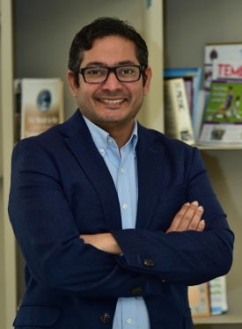

Dr. Farhan Cyprian,

Associate Professor of Immunology
College of Medicine, Qatar University
P.O. Box 2713
Doha, Qatar
Phone: +974 4403 7830
Email: fcyprian@qu.edu.qa

Dr. Cyprian served as an assistant professor at the College of Medicine, UoS, UAE prior to joining CMED at Qatar University. He was working at Sharjah Institute for Medical Research where he contributed in the establishment of many active research projects in addition to designing the animal facility. Trained as a physician he joined cancer research at Prof Philippe Bouvet lab in ENS Lyon identifying the formation of nucleolin at the transcriptomic level and later at Institut Mérieux and Centre Leon Berard Lyon, France, Elucidating T cell regulation by regulatory factors such as transforming growth factor beta (TGF‐β).
Google Scholar: https://scholar.google.com/citations?user=oKsJU6YAAAAJ&hl=en

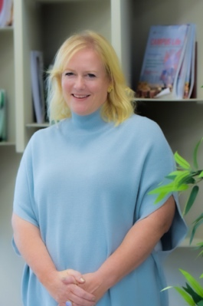
Dr. Tanya Kane,

Associate Professor of Behavioral Science
College of Medicine, Qatar University
P.O. Box 2713
Doha, Qatar
Phone: +974 4403 7845
Email: tkane@qu.edu.qa

Tanya Kane is an Assistant Professor of Behavioral Science in the College of Medicine at the University of Qatar. She holds a Ph.D. and MSc in Anthropology from the University of Edinburgh, an MA from McMaster University, a BEd from the University of Toronto, and a BA from Queen’s University (Canada). Her research interests include globalization of higher education, knowledge-based economies, medicine and gender, especially in relation to the countries of the Arabian Peninsula. Tanya’s current research project is examining the psychosocial dimensions of infertility in Qatar. Her previous work has focused on dementia, cultures of expertise, the intersection of religious and scientific knowledge, language in transnational education and the universality of medicine. Dr. Kane has held posts at Northwestern University in Qatar, Texas A&M University at Qatar and Virginia Commonwealth University in Qatar. A former teacher, she has taught in Canada and the United Kingdom.
Google Scholar: https://scholar.google.com/citations?user=bhrsdZgAAAAJ&hl=en

